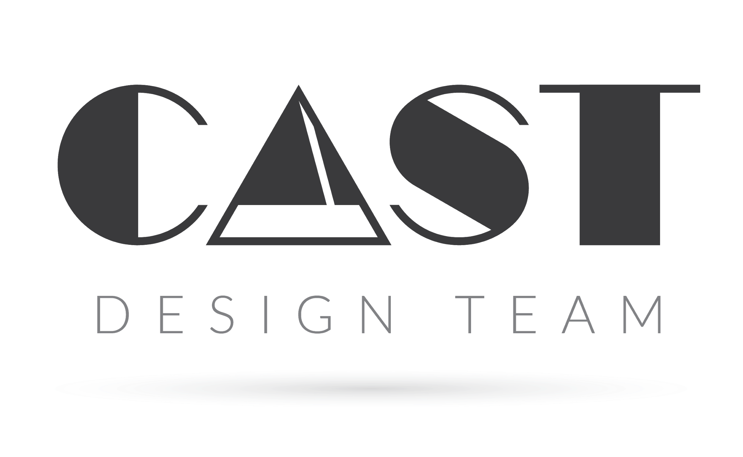
WEBSITE ASSESSMENT

PART 1 | ABOUT YOUR BUSINESS

- What is the name of the company?
- What industry does your business operate in?
- Do you currently have a website up? If so, what is the URL?
- Who is your website hosted with?
- What frustrates you about your current website?
PART 2 | BACKGROUND INFORMATION

- What type of services do you offer?
- What problems do your clients have that your organization solves? What makes you different?
- Are you a non-profit? If so please name some peer organizations that are similar to yours.
- Who are your main competitors?
- Why do you want to have a new website? What are your priorities?
- Describe the desired look and feel by using adjectives and short phrases.
- If your website where a person, which of the following word clouds do you feel would best describe them?
A. Sincere - Down to earth, honest, wholesome, cheerful
B. Exciting - Daring, Spirited, Contemporary, Imaginative
C. Competent - Reliable, Intelligent, Successful
D. Sophisticated - Classy, Glamorous, Charming, Smooth

PART 3 | ABOUT YOUR TARGET MARKET

- What is your target customers’ gender?
- How old are your target customers?
- What is their average household income?
- How will they find and learn about your brand?
- Which of the following marketing inputs is most likely to influence your customer's' buying decision?
A. Product
B. Place
C. Promotion
D. Price
- What else can you tell us about your customers?
Briefly describe their values, decision-making process and, if you already have a brand, how they currently perceive it.
PART 4 | BRAND IDENTITY

- What is your brand mission?
Let us know about your brand values and what you want your brand to ultimately be and do.
- What is your tagline?
- Do you have a high-resolution logo?
- Do you have a style guide or brand standards?
- What fonts do you typically use?
- Are there any colors that you want incorporated into the website?
- Do you have established print materials? Please send us a copy.
- If you were using a search engine, what words or phrases would you use to find your site?

PART 5 | INSPIRATION

Please list 3 websites that you are in love with and explain why.

PART 6 | CONTENT
- Approximately many static pages do you need? (Ex: About, Contact Us, Donate, FAQ, etc.) A ballpark number is fine.
- We would like to have these types of pages as part of our site. Highlight All that apply.
A. Testimonials
B. Donation Page
C. Staff
D. Client List
E. Programs
F. FAQ’s
G. Services
H. Portfolio
I. News & Events
- Do you currently have content that you want to use?
- Would you like the content to be prepped and SEO ready with keyword integration? Additional fees apply.
- Do you have high resolution photos and/or videos that you want to incorporate into your website?
- Would you like a quote for photography and video?
- When the website is completed, who will take over the maintenance?
PART 7 | FEATURES

- What type of features will the website have? Highlight all that apply.
A. E-Commerce
B. Donations
C. Login/Account
D. Restricted Content
E. Membership
F. Booking Calendar
G. Newsletter Opt-In
H. Search Function
I. Social Media Feeds
J. Case Studies
- Please list all of your Social Media accounts with links. If you would like a social media feen on the website, also give us the login information for that channel.
- Are there any other website functions that you need?
PART 8 | ABOUT YOU
- What is your budget range for this project?
- What are your objectives and expectations for this project?
- Are you the decision maker for this project?
- What is your preferred deadline for completing the site?
- Do you have extra information, comments or requests you would like us to consider?*
- Anything else we can help you with or any connections you are looking to make?

