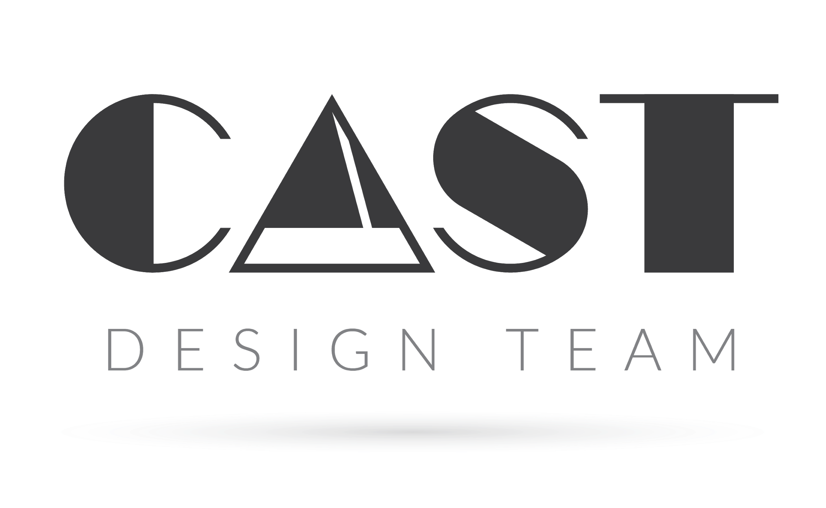
BRANDING ASSESSMENT

PART 1 | ABOUT YOUR BUSINESS

- What is the name of the company?
- What industry does your business operate in?
- What are the key points in the history of your business?
- Who are your main competitors?
- What is the single most important thing that sets your business apart from the competition?

- What's the story behind your current brand?

- Where do you see your brand in 10 years?

- How Do You Make Your Clients Feel?
PART 2 | ABOUT YOUR BRAND

- What are we branding? A service, product or company.
- What is the name of the brand?
- Where can we find your website, if you have one?
- What is your brand mission?
- If your brand where a person, which of the following word clouds do you feel would best describe them?
A. Sincere - Down to earth, honest, wholesome, cheerful
B. Exciting - Daring, Spirited, Contemporary, Imaginative
C. Competent - Reliable, Intelligent, Successful
D. Sophisticated - Classy, Glamorous, Charming, Smooth
- What problem does your company solve?

- What are the emotional benefits that only you deliver to our customers?

PART 3 | ABOUT YOUR TARGET MARKET

- What is your target customers’ gender?
- How old are your target customers?
- What is their average household income?
- How will they find and learn about your brand?
- Which of the following marketing inputs is most likely to influence your customer's' buying decision?
A. Product
B. Place
C. Promotion
D. Price
- What else can you tell us about your customers?
Briefly describe their values, decision-making process and, if you already have a brand, how they currently perceive it.

- What are you ideal customers' biggest pain points?

- Why should your target audience choose your product or service above your competitors?

- Are there any audiences you aren't currently reaching that you want to reach with your brand?

- Why Do Your Clients Trust You?
PART 4 | ABOUT THIS PROJECT

- Which of the following designs would suit your brand the best?
A. TECHY

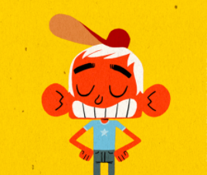
B. ILLUSTRATIVE

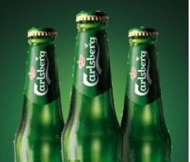
C. PRODUCT BASED

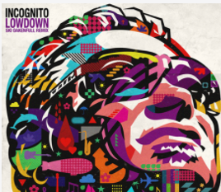
D. FLASHY

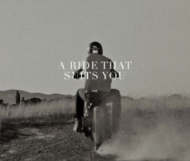
E.PHOTO-BASED

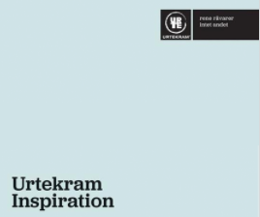
VF. MINIMAL
- What colors do you feel best represents your brand?

- And if you had to choose one of these fonts for your brand, which would you choose?
Aa
Classic

Aa
Serif

Aa
Rounded

Aa
Modern

Aa
Script

- What are your objectives and expectations for this project?

- What's Wrong with Your Existing Brand Identity (if applicable)?

- How Does Your Logo Communicate Your Brand (if applicable)?
- Can you name a few examples of brands you admire?
- Are there any particular adjectives you people to associate with your brand?
- Do you have established print materials? Please send us a copy.

- What Does Your Voice Sound Like?
- Who is the key decision-maker on your team?

